Glyoxime, Diaminofurazan
and some Energetic Derivatives
Hydroxylamine Hydrochloride
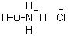
Hydroxylamine can be formed by acid hydrolysis of nitromethane[1] forming the acid salt of hydroxylamine and formic acid.
CH₃NO₂ + HCl + H₂O → NH₂OH.HCl + HCOOH
Hydroxylamine hydrochloride: 61g nitromethane was mixed with 114g 32% hydrochloric acid in a 300ml glass bottle (molar ratio CH3NO2/HCl/H2O 1:1:4.3). The top was screwed on the bottle and it was immersed in an oil bath heated to 100°C (figure 1). The solution was left at this temperature for 24 hours whereby the nitromethane and acid layers formed a homogeneous solution.
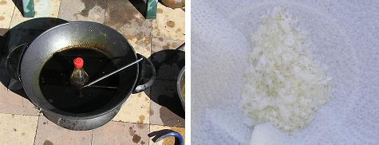
Figure 1: CH3NO2/HCl solution in oil bath (left). NH2OH.HCl crystals (right)
The solution was then transfered to a wide mouth beaker and left at the same temperature until evaporated to about 1/3 of its initial volume. On cooling the solution to -5°C hydroxylamine hydrochloride precipitated as large white flakes which were filtered and dried, further concentration and cooling yielded more crystals for a total of 41g (59%).
A similar process to that described above was used but with a molar ratio of 1:1:10, this allowed the solution to be heated in a non-pressurized vessel without significant loss of HCl, plastic film and a rubber band was used to cover the flask containing the solution. The solution was heated for 40 hours at 100°C and concentrated and precipitated as before, yield was 32g (46%).
When heated on a spoon the NH2OH.HCl decomposed energetically with release of white smoke but no flame.
Glyoxime
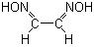
Glyoxime also known as ethandial dioxime is produced by the condensation of glyoxal with hydroxylamine in slightly acidic solution, the following is an adaptation of the literature method[17].
Glyoxime: 27.5g (0.69mol) sodium hydroxide was dissolved into 75ml water and cooled to 0°C, 69.5g hydroxylamine hydrochloride (1mol) was then added with stirring. To the still chilled solution was then slowly added 72.5g (0.5mol) of 40% glyoxal in 48ml water maintaining temperature below 10°C. The solution was left in the fridge for 15 minutes then removed and allowed to come to room temperature. The solution become solid with precipitate within 1 hour which was scooped out and pressed as dry as possible between absorbent paper, The damp glyoxime was then left sandwiched between 4 sheets of absorbent paper to dry (figure 2), this allowed the salt solution to be wicked out of the glyoxime to deposit the NaCl in the upper layers of paper. The crude yield of glyoxime was 38g (86%). The crude glyoxime was recrystalised from ether to form the most pure product, this was used for the lead and silver salts below.
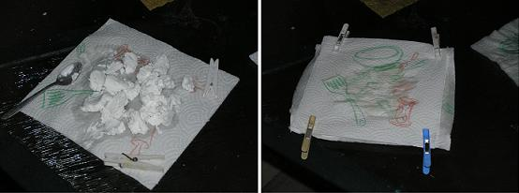
Figure 2: Drying glyoxime
The recrystalised glyoxime melts at 178°C with decomposition and ignites easily when touched with the flame of a match, burning mildly with a soft orange flame and faint “hiss”.
Glyoximate Salts
Glyoxime is acidic, and carries the energetic oxime groups, thus is capable of forming salts that may show notable explosive characteristics. Bretherick[2] lists a basic copper salt (HOCuON=CHCH=NOH) which is said to lose weight up to 140°C before exploding.
The silver and lead salts were produced by precipitation of a solution of sodium glyoximate with silver nitrate and lead acetate. These salts were shown to have interesting primary explosive qualities but are unlikely to have, nor were they tested for initiating ability.
Silver glyoximate: Into 2g (23mmol) of glyoxime in 50ml water was added 1.8g (45mmol) of sodium hydroxide to produce a solution of sodium glyoximate. Into this solution was added 3.9g (46mmol) of silver nitrate in 20ml water which resulted in the immediate precipitation of a grayish maroon coloured silver glyoximate, which was filtered and dried out of sunlight. The dried salt was found to darken when exposed to sunlight and flash with a “thump” on ignition (figure 3). Eventually the silver salt exploded by itself when left in direct sunlight.
Lead glyoximate: Lead glyoximate was produced in the same way as the silver salt, except 7.4g (23mmol) of lead acetate was used to precipitate the lead glyoximate as a fine, flocculent white precipitate. The lead salt on ignition exploded with more vehemence then the silver salt, exploding with a loud report in quantities over about 1g (figure 3).
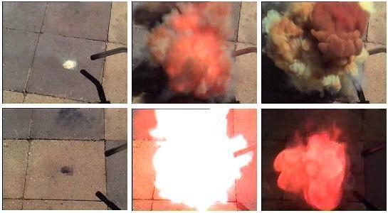
Figure 3: Ignition of 0.8g lead glyoximate (top) and 0.5g silver glyoximate (bottom)
Nitroglyoxime
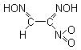
The activated hydrogen of glyoxime is capable of reacting with nitric acid containing HNO2[3] or with nitrogen dioxide itself[4] yielding nitroglyoxime, an explosive nitrolic acid.
Nitroglyoxime is too unstable to be of any practical use, it melts at 111°C with decomposition and explodes on further heating[4]. It is soluble in water (decomposed by hot water) alcohol, ether and acetone, very slightly soluble in benzene, more so in boiling benzene. It is insoluble in chloroform and petroleum ether[4].
The basic lead salt of nitroglyoxime (C2H2N3O4.Pb.O.Pb.C2H2N3O4) was first reported by Bamberger[4] as being the yellow precipitate that forms from combining aqueous solutions of nitroglyoxime and lead acetate, and is said to explode when ignited. Bamberger also formed explosive hydrazine, potassium and silver salts.
Nitroglyoxime: 5g glyoxime was dissolved into 150ml diethyl ether, and poured into a 250ml measuring cylinder. Nitrogen dioxide was produced by reacting a piece of copper pipe with 85ml 70% nitric acid, this red gas was piped using PVC tubing into another flask to cool the gas and condense and trap any liquid, and from that flask into the measuring cylinder holding the glyoxime solution (figure 4). The nitrogen dioxide was passed through the solution until the reactor was exhausted. The ether solution was filtered and evaporated in a 1000ml wide form beaker in the sun until dry.
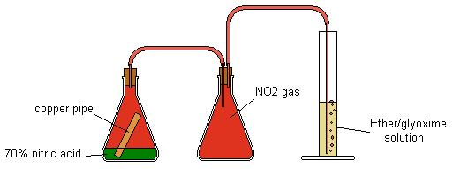
Figure 4: Nitroglyoxime apparatus
The only product obtained was a yellowish red explosive oil that smelled of nitrogen oxides and flashed when heated on a spoon.
To reclaim any nitroglyoxime that may have been present in the oil, it was poured into an aqueous solution of lead acetate this produced a red solution and a small quantity of yellow precipitate that was filtered and dried. In small quantities the putative lead nitroglyoximate flashed when ignited from a flame (figure 5). Glyoxime itself will not form a precipitate from lead acetate.
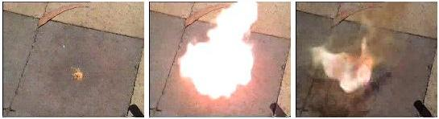
Figure 5: Ignition of 0.1g putative lead nitroglyoximate
The synthesis of nitroglyoxime was also attempted by the action of N2O4 on solid glyoxime, when a stream of NO2 was piped over the glyoxime in an improvised glass condensor cooled by NH4NO3/H2O, the reaction was hypergolic, bursting into flames.
A review article by Riebsomer[6] shows reactions of nitrogen oxides with oximes, which mentions that the oxime/glyoxime groups themselves are open to attack from NO2. For example the primary product of nitrogen dioxide acting on dimethyl, methyl, ethyl methyl and phenyl glyoxime in ether was a glyoxime peroxide containing a R-C=N-O-O-N=C-R ring bound through the carbons. The reactions of glyoxime itself are not mentioned and no references to the glyoxime peroxide structure could be found in recent literature.
Diaminoglyoxime (DAG)
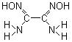
Diaminoglyoxime also known as oxamidoxime has been prepared by numerous ways, such as from cyanogen and hydroxylamine[15], ammonolysis of dichloroglyoxime diacetate, from dibromofuroxan and ammonia, by the reaction of dithiooxamide (rubeanic acid) with hydroxylamine[23], glyoxime with hydroxylamine[24] but most conveniently in one step through the condensation of glyoxal and hydroxylamine[16] . DAG is soluble in hot water though difficultly soluble in cold water and alcohol[7] so is readily precipitated, and recrystalised from aqueous solution.
Diaminoglyoxime from glyoxime: Into a beaker containing a solution of 20g (0.5mol) sodium hydroxide in 90ml water was added 17.6g (0.2mol) glyoxime. 27.8g (0.4mol) hydroxylamine hydrochloride was then added in one portion. An improvised reflux condenser was added to the beaker (figure 6) and it was heated in an oil bath at 90°C for 6 hours. After the 6 hours the solution was cooled to room temperature which precipitated diaminoglyoxime as small fine needles (figure 7) which were filtered and dried. Yield was 12.2g (51%)
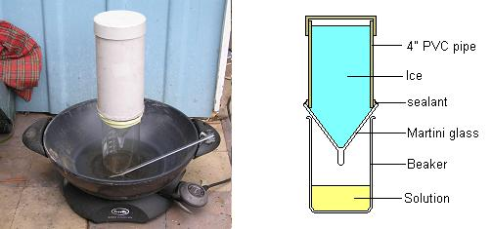
Figure 6: Reflux apparatus for glyoxime/glyoxal to diaminoglyoxime condensation

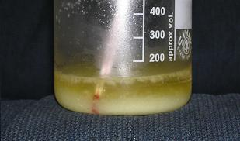
Figure 7: Precipitate of diaminoglyoxime
Diaminoglyoxime from glyoxal: 140g (3.5mol) sodium hydroxide was dissolved into 400ml water, the solution was cooled down to 0°C and 222g (3.2mol) hydroxylamine hydrochloride was added in portions with stirring. To the still cold solution was added 116g (0.8mol) of 40% glyoxal in one portion. The solution was left in the freezer for 10 minutes then placed in an oil bath heated to 90-100°C (figure 6) for 5 hours. After this time a precipitate had formed in the solution, it was taken off the heat and cooled to 0°C. The large crystalline precipitate was filtered, placed in another beaker and enough water was added to make up 400ml of solution. This was boiled to redissolve the DAG then on slow cooling long straw-like crystals formed in the solution (figure 8), these were filtered and dried. Yield after recrystalisation was 38g (40%).
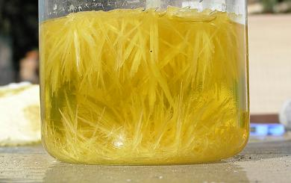
Figure 8: Recrystalisation of diaminoglyoxime
3,4-Diaminofurazan (DAF)
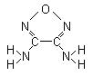
Diaminofurazan is the precursor to a wide range of energetic substances carrying the furazan ring, furazans have many desirable properties for an energetic material such as its dense planar structure, stabilizing aromatic nature and energetic oxygen in the ring, many furazan derivatives also have a very high heat of formation.
DAF is formed from the base catalysed dehydration and cyclisation of diaminoglyoxime by aqueous sodium[23] or preferably potassium hydroxide[24,18] at 180°C. Recently a convenient microwave mediated synthesis has also been reported[22].
DAF melts at 180°C, decomposes an 240°C and has a density of 1.61g/cm3 [25].
Diaminofurazan: 9g potassium hydroxide was dissolved into 76ml water, then poured over 24g diaminoglyoxime in a stainless steel reactor (figure 9). The reactor was made by welding together stainless steel water pipe fittings and had a capacity of 270ml. The reactor was immersed into oil and heated up to 180°C over 30 minutes and then left for two hours at 170-180°C, after this time the hotplate was then turned off and allowed to cool slowly. On opening the reactor a small amount of pressure was released and the solution smelled strongly of ammonia. A quantity of small white needle like crystals (figure 10) had precipitated which were filtered and dried. Yield was 8.6g (42%) of DAF.
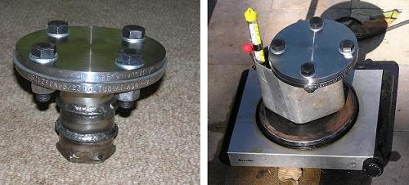
Figure 9: Stainless steel reactor

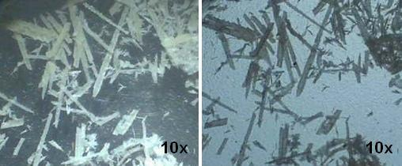
Figure 10: Crystals of 3,4-diaminofurazan in transmitted and reflected light
DAF, being a weak base has been shown to form a nitrate salt, however the weakly bound nitric acid is lost when drying under vaccuum[5]. It also will form stable complexes with some metal salts such as with copper nitrate, Cu(DAF)₂(H₂O)₂(NO₃)₂ [5].
3,3’-Diamino-4,4’-azoxyfurazan (DAAF)
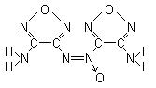
While DAAF is yet to find commercial or military use due to limited commercial production, its explosive properties (table 1) show it to be a practical and powerful explosive. DAAF has a relatively high density, low sensitivity to impact and a high velocity of detonation. DAAF also has acceptable thermal stability, melting with decomposition at 249°C[14].
DAAF is formed by the oxidation of DAF by a mixture of hydrogen peroxide and sulphuric acid[9].
3,3’-Diamino-4,4’-azoxyfurazan: Into 15g 50% hydrogen peroxide was added 10g crushed ice, then 14g sulphuric acid was dripped in maintaining temperature below 20°C. This solution was then poured over 2.5g diaminofurazan in a 80ml beaker. The suspension was stirred by use of a drill press, whereby the DAF went into solution imparting a green colour from the formed, soluble nitroso compound. Within an hour the green colour gave way to orange due to a fine precipitate of DAAF (figure 11). The solution was stirred for 9 hours then left for a further 15 for a total of 24 hours. The mixture was then diluted with an equal volume of water, filtered to recover a fine orange crystals (figure 12), washed with 200ml of cold water and dried. Yield after bottling was 1.5g (57%).
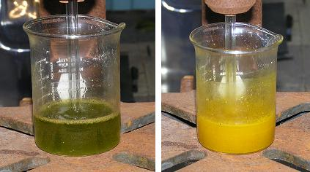
Figure 11: Colour change during oxidation of DAF to DAAF

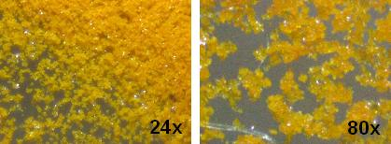
Figure 12: Crystals of DAAF
3,3’-Dinitro-4,4’-azoxyfurazan (DNAF)
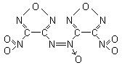
Further oxidation of amine groups on DAAF results in the extremely powerful explosive 3,3'-dinitroazoxyfurazan. DNAF’s explosive properties rate it as one of the most powerful of the conventional explosives with exceedingly high velocity of detonation, very high heat of formation and good oxygen balance. DNAF is also castable, melting at 110-112°C and boiling at 270°C[18]. However its main fault is its high sensitivity to impact, being neary twice as sensitive as PETN, which would limit practical use. DNAF’s explosive properties are listed in table 1.
The literature methods for DAAF oxidation to DNAF requires ammonium persulphate[18,19] or sodium persulphate[8], with hydrogen peroxide and sulphuric acid, yield was 60%. DNAF can also be formed in by direct oxidation of 3,3’-diamino-4,4’-azofurazan or DAF, but with reduced yield (15% & 4% respectively[18]).
3,3’-Dinitro-4,4’-azoxyfurazan: Into a 250ml conical beaker was added 27.5g 50% hydrogen peroxide diluted with 17.5ml water it was then chilled to 5°C. 30g ammonium persulphate was then dissolved into the peroxide solution and left to cool in the freezer. Another solution was made by dissolving 2.5g DAAF into 32g 98% sulphuric acid and was slowly added to the cooled peroxide solution maintaining the temperature below 20°C, on addition the DAAF precipitated as a very fine orange suspension. The beaker was then placed in an oil bath heated to 40°C and stirred by use of a drill press (figure 13). Good stirring must be used to churn the foam that is created during the oxidation. This was maintained for 8 hours whereby the orange solution turned bright yellow. The solution was then drowned in 200ml ice cold water and filtered, flushed with more water then dissolved into 150ml dichloromethane, the DCM solution was then washed with dilute sodium bicarbonate/water solution. The Yellow DCM solution was then separated and evaporated to yield yellow crystals of DNAF (figure 13). Yield was 1.3g (40%).
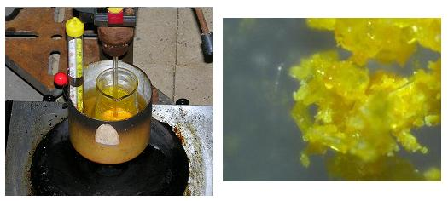
Figure 13: Oxidation of DAAF to DNAF (left); DNAF crystals (right)

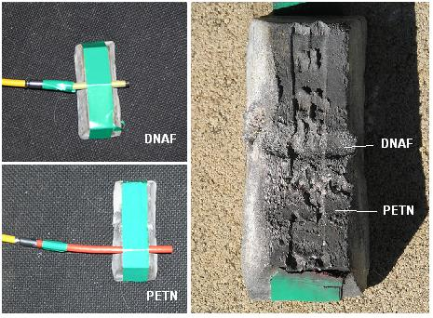
Figure 14: DNAF & PETN detonated against lead block

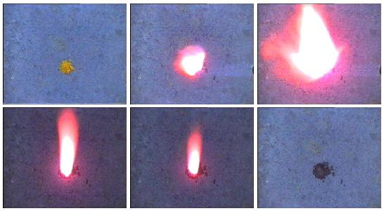
Figure 15: Ignition of DNAF
The DNAF was pressed into a drinking straw, taped to a lead block, buried under sand and detonated. PETN detonating cord was used for comparison (figure 14). When touched with a match DNAF will melt then ignite and burn vigorously with a luminous smokeless flame (figure 15).

3-amino-3’-azido-4,4’-azoxyfurazan (AAAF)
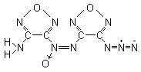
DAAF, being a basic, aromatic primary amine is open to diazotisation and subsequent reactions. The azido and diazido derivative of DAF is known to the literature[18,21]. DAAF like DAF has only weakly basic properties thus diazotisation must be carried out in nitrosylsulphuric acid, and the formed diazonium sulphate salt of these furazans is not stable enough to be isolated[20]. AAAF is formed by reacting a 3-amino-4,4’-azoxyfurazan-3‘-diazonium sulphate solution with sodium azide[18].
2H₂SO₄ + NaNO₂ → NO.HSO₄ + NaHSO₄ + H₂O
NO.HSO₄ + Fz-NH₂ → [Fz-NH-NO] → [Fz-N≡N.OH] → Fz-N≡N.HSO₄ + H₂O
Fz-N≡N.HSO₄ + NaN₃ → Fz-N=N=N + NaHSO₄ + N₂
The substitution of one amino group with an azido group greatly increases the energetic potential of DAAF with AAAF having calculated explosive properties similar to that of HNIW (table 1). The crude un-neutralized product on drying turned from light yellow to orange, and flashed on ignition by flame (figure 16).
3-amino-3’-azidoazoxyfurazan: 1g (15 mmol) sodium nitrite was dissolved in 28g 98% sulphuric acid and combined with a solution of 1.1g (5 mmol) DAAF in 18g 98% sulphuric acid while keeping temperature at 0-5C. Maintaining the temperature at 0-5°C the combined solution was diluted with 26g glacial acetic acid, then with good cooling was treated with 1g (15 mmol) sodium azide in 20g water drop by drop over 30 minutes, not letting the temperature rise over 5°C. On addition of the sodium azide the solution foamed with release of nitrogen and turned from dark orange to light yellow. The solution was then left for a further 15 minutes then drowned in 300ml cold water. A light yellow precipitate of AAAF was filtered, flushed with water and dried. Yield was 0.6g.
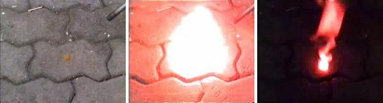
Figure 16: Ignition of AAAF

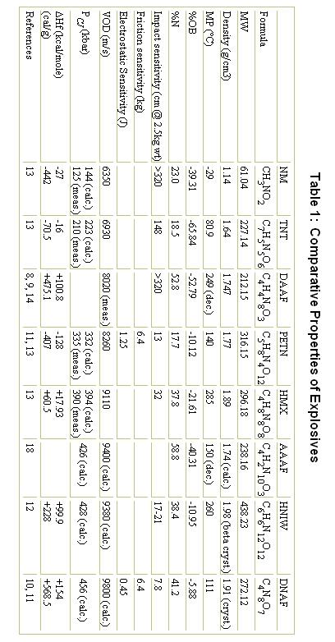

References
1] Pratorius-Seidler, G. “Zur Kenntniss des Cyanamids” Journal für praktische Chemie, 21, 129-150 (1880)
2] Urben, Peter (editor: Leslie Bretherick). "Bretherick’s Handbook of Reactive Chemical Hazards". 5th ed. vol. 1, 0799. Butterworth-Heinemann, 1999.
3] E. Bamberger & U. Suzuki, “Űber Nitro-Glyoxim” Berichte der Deutschen Chemischen Gesellschaft, 45, 2740-2758, (1912)
4] Fedoroff, B. et al. “Encyclopedia of Explosives and Related Items“. vol. 6 pg. G119. (1974)
5] C. E. Stoner et. al., “Thermal Decomposition of Energetic Materials. 48. Structures and Decomposition Mechanisms of Copper (II) Complexes of Furazans ( 1,2,5-Oxadiazoles)”. Journal of Inorganic Chemistry, 30, 360-364, 1991.
6] J. L Riebsomer, “The Reactions of Nitrogen Tetroxide with Organic Compounds”, Chemical Reviews, 36, 157-233, 1945.
7]Banks, C & Voter, R. “Water-Soluble 1,2-Dioximes as Analytical Reagents” Analytical Chemistry.; 21(11); 1320-1323 (1949)
8] Cannizzo, L. Hamilton, R. Highsmith, T. "Furazan-Based Energetic Ingredients". Thiokol Propulsion, Brigham City. USA. (1999)
9] Hiskey, M. et. al. "Use of 3,3'-diamino-4,4'-azoxyfurazan and 3,3'-diamino-4,4’-azofurazan as insensitive high explosive materials". US patent #6358339 (2002)
10] Sheremetev, A. et al. "Dinitro Trifurazans with Oxy, Azo and Azoxy Bridges". PEP, 23, pg. 142-149. (1998)
11] Zelenin, A., Stevens, E. and Trudell, M. "Synthesis and structure of 4-[(4-nitro-1,2,5-oxadiazol-3-YL)-NNO-azoxyl]-1,2,5-oxadiazol-3-amine" Office of Naval Research, University of Illinois at Urbana-Champaign. (1996).
12] Nielsen, A. "Caged polynitramine compound" US patent #5693794 (1997)
13] Dobratz, B and Crawford, P. "LLNL Explosives Handbook - Properties of Chemical Explosives and Explosive Simulants" Lawrence Livermore National Laboratory. California. (1985)
14] Beal, R & Brill, T. "Thermal Decomposition of Energetic Materials 77. Behavior of N-N Bridged Bifurazan Compounds on Slow and Fast Heating" PEP, 25, 241-246 (2000)
15] Barham, D. et. al. “The Structure of Amidoximes. II. Oxamidoxime” Journal of Organic Chemistry.; 1963; 28(1); 134-136.
16] Trudell, M & Zelenin, A. “A Two Step Synthesis of Diaminofurazan and Synthesis of N-Monoarylmethyl and N,N’-Diarylmethyl Derivatives” Journal of Heterocyclic Chemistry, 34, 1057 (1997)
17] Michelman, J & Olofson, R. “Furazan” Journal of Organic Chemistry, 30(6), 1854-1859 (1965)
18] Boyer, J., Gunasekaran, A. & Trudell, M. "Dense Energetic Compounds of C, H, N, and O Atoms. IV. Nitro and Azidofurazan derivatives" Heteroatom Chemistry. 5 [5/6], 441 (1999)
19] Beal, R. “Structures and Chemistry of Amino and Nitro Furazans” Thesis, University of Delaware (2000)
20] Rakitin, O. et. al. “Synthesis and reactivity of furazanyl- and furoxanyldiazonium salts” Russian Chemical Bulletin, 42, No. 11, 1865-1870 (1993)
21] Tselinskii, I; Mel'nikova, S; and Vergizov, S; Zh.. Org. Khim., 17, 1123 (1981) [“Azido Furazans in the Synthesis of Condensed Systems” Russian Journal of Organic Chemistry., 17 (1981) (Engl. Transl.)].
22] Kusurkar, R. et. al. “Microwave mediated fast synthesis of diaminoglyoxime and 3,4-diaminofurazan: key synthons for the synthesis of high energy density materials”. Journal of Chemical Research, April, 245-247 (2005)
23] Boyer, J. and Gunasekaran, A. “Dense Energetic Compounds of C, H, N, and 0 Atoms. III. 5-[4-Nitro-(1,2,5) oxadiazolyl]-5H-[1,2,3]triazolo[4,5-c][1,2,5]oxdiazole” Heteroatom Chemistry 4[5], 521-524. (1993)
24] Gunasekaran, A.; Jayachandran, T.; Boyer, J. & Trudell M. “A Convenient Synthesis of Diaminoglyoxime and Diaminofurazan: Useful Precursors for the Synthesis of High Density Energetic Materials”. Journal of Heterocyclic Chemistry, 32, 1405-1407, (1995)
25] Sheremetev, A. et. al. “Furazan Derivatives,: High Energetic Materials From Diaminofurazan”. Proceedings of 22nd International Pyrotechnics Seminar. Fort Collins, Colorado. 377-388. (1996)
Thanks goes to Chris the Great for sourcing 8, 11, 19 and 24. Also thanks to Chemoleo for translating 1 and 3.
[Edited on 19-5-2006 by Axt]

